Physical Facilities Operation and Maintenance Plan  Tom P. Haney Technical College | 
Physical Facilities
Tom P. Haney Technical College is located at 3016 Hwy 77, Panama City, FL 32405. The school was built in 1968 and a major renovations project of the administrative building was completed in 2006. All programs have been renovated through the years. The school suffered major damage in a category five hurricane in 2018 and again in 2021 with a tornado. Four damaged buildings were demolished in 2022, and Phase 1 of construction for a new two-story building to house health science, IT, and business programs along Hwy 77 began. The new building opened for student use in January 2024.

Budget for Facility Maintenance and Improvement
Tom P. Haney Technical College operates under the auspices of Bay District Schools. Bay District Schools operates an in-house maintenance and facilities department. The college requests services from the maintenance department on an as-needed basis via Bigfoot, an online management platform. Staff members communicate maintenance requests to the Tom P. Haney Technical College administrator over facilities. Requests are then entered into Bigfoot by an administrator or the administrative secretary and scheduled for repair. Bay District School’s Maintenance Department is located adjacent to Haney’s campus. Basic maintenance issues that can be handled internally are resolved by the custodial staff. Limited maintenance and repairs of equipment are handled in-house. The School District Maintenance Department handles repairs of most equipment. Repairs of equipment not covered by District Maintenance are made by the appropriate vendor or, if applicable, by a qualified Haney program instructor. Due to the age of the school and the destruction caused by Hurricane Michael in October 2018, there is continuous maintenance on campus. Preventive maintenance takes place regularly.

Personnel:
The Physical Facilities and Technical Infrastructure plan is administered and maintained by the college’s administrator over facilities. Facilities/Repair/Maintenance responsibilities for various departments such as Custodial Staff, Maintenance Department, Bay District Schools ITV, Bay District Schools MIS, Chartwell (kitchen/food service), and lawn maintenance, etc., are designated in this document.

Non-Instructional Equipment and Supplies:
Expenditures for equipment, technology, and supplies are budgeted at a level to assure they are adequate to support quality educational programs offered by the institution. Expenditures are from budgeted workforce development funds, performance-based incentive funding, federal projects, grants, and consumable supply fees. Other monies are available from internal accounts.

Tom P. Haney Technical College uses an inventory management system that accounts for the location of equipment, and for the purchasing and disposition of equipment according to Bay District School Board policy. Equipment inventory records are kept by the College and the Inventory Records Section of Bay District Schools. To further track inventory in each program/area, an Inventory Record form is used. When the district office dispenses a purchase order, a Master Inventory Record Card is used and maintained for each piece of equipment or furniture valued at $2500 or more or $1000 if it is purchased with a federal grant. Each piece of equipment listed on the district inventory is labeled with a number that corresponds with the number on the Master Inventory Record Card. Items valued at less than the designated cutoff amount are labeled and kept on inventory records maintained at the campus.

Some technology is managed through Destiny, an online inventory system utilized through media services, which is used for checking out equipment to individuals. Whenever equipment is transferred on campus, the property administrator must be notified with an In-School Inventory Transfer form so that the change in location may be noted on the Master Inventory Record Card.

Federal grants, when available, provide some assistance with new equipment acquisition. Equipment requests at the College are prioritized by administration and are based on program need and condition of the equipment in use. The program instructor is responsible for advising the administration of specific equipment requirements.

Instructors employ alternate means to supplement equipment purchases and maintenance to include simulators, donation of equipment from manufacturers and contractors, and internal funds generated from shop job orders.

A Request for Inventory Adjustment form must be submitted to the College’s property administrator to remove property from inventory. Items may be removed for the following reasons: obsolete, beyond economical repair, no longer used, or transferred. An Equipment Replacement Plan is in place for replacing obsolete equipment. The replacement plan is also used for purchasing new equipment on an as-needed basis with the availability of funds. The specific details of these plans are found in the Maintenance and Replacement Plan for Media Services.

Relevant State Law, Federal Codes, and Procedures
The college has a comprehensive fire prevention and control program, as well as a safety and emergency procedure program, called the Health and Safety Plan. All facilities meet fire and safety codes with fire extinguishers well-marked and easily accessible. The fire alarm system operates campus-wide and emergency evacuation and safety drills are conducted once each month. Predetermined exit routes and evacuation/shelter plans are well marked and posted in each area throughout the school. Telephones are equipped with emergency buttons and readily available to call for help. The operator has a two-way radio to disseminate information to administration and custodial staff who also carry two-way radios. Each classroom or shop is issued a Bay District Schools Emergency Procedures Quick Reference Guide, which outlines the procedures for emergency care in the event of an accident. Material Safety Data sheets are posted in each program area.

Inspections are done on a regular basis by the Bay County Health Department, Lynn Haven Fire & Emergency Services, and Code South. An annual walkthrough takes place each summer, that involves school administration, Lynn Haven Police Department, Lynn Haven Fire Department, and Bay District Schools Resource Officer(s). If any discrepancies or recommendations are noted, corrections are normally made before a follow-up inspection. Periodically, fire/safety inspections are done on the campus.

Annual Availability and Evaluation of Plan
The plan is made available to staff annually and is available on the digital V drive which is accessible to all school staff. The plans are housed on the school’s website under the Disclosures tab for constant access. The plan is emailed annually to all staff for review. Revisions are made as needed.

Appendix
BIGFOOT CMMS USER GUIDE

GENERAL INFORMATION
When to call Facilities:
- If you have a problem with a new portable that is being installed at your school. (i.e.: plumbing, electrical, moving)
- If a new building or renovation project is in the planning stage or if it is still In process.

When to call Maintenance:
- Once the new project has been completed and accepted by Facilities then it comes to Maintenance for us to take care of.
- Maintenance maintains what is already there.
WHEN IN DOUBT CALL MAINTENANCE FIRST
Roof Leaks: Call Work Control @ 767-1822, to report it. (If A Work Order request has already been entered for the same location…for the same School Calendar year, DON’T ENTER A NEW WORK ORDER. Call in and give the Work Order # that was entered at the beginning of the year. We will document it on the Work order to show a history then we’ll send to Facilities. ) Facilities will contract out all roof leaks.
Fire Alarm and Fire Sprinkler calls: Enter a Request and then call Work Control @ 767-1821. On the request, document what the fire panel states the problem is.
(A Supervisor will determine if we need to send a Maintenance Tech. out or if we can forward the Request directly to Ivanco or Simplex- Girrnell.)
Please do not call IVANCO directly during the school work day.
INSPECTION REPORTS
Safety Inspection, Fire Inspection and Playground Inspection Reports: Will be given to Facilities. They will generate the work orders for your school
HRS REPORTS: are sent to the maintenance supervisor. Maintenance will generate the work order for your school. (If you have a write up, check your “List” for your work order #. If you do not see a work order, please contact Maintenance.)
Burglar Alarms: School is responsible for contacting their servicing company.
Elevator Problems: School is responsible for contacting their servicing company.
Warranty Problems: Call Work Control @ 767-1821
County Mowers, Floor Machines, and Pressure Washers: E-mail your request to Angela Vancamp to get on a Rotation Schedule. Maintenance will deliver them to you on Monday and pick them up on Wednesday. Mowers will be loaned only to elementary schools.
Replacing projector bulbs, cleaning projectors, smartboard issues: Call ITV @ Media Center 767-4666.
Audio Visual Repair: Call ITV @ the Media Center 767-4666.
Phone Lines, Computer or Intercoms: Call Help Desk @ 767-4150.
Food Service (kitchen): Call Chartwells at 767-4281 to enter in a work request. If it is an Emergency, call us to up-grade the request.
*** Pest Control Problems where FOOD IS COOKED, SERVED OR STORED you need to call FOOD SERVICE @ 767-4281
VANDALISM:
Call the Police or Sheriff Dept. to get a report. If a report is not made you still need to do the following:
1. Enter work request into the Bigfoot CMMS system. Get work order number.
2. Call Risk Management @ 767-5297 to report vandalism and give them your work order number. Fax the Police Report (Property Loss) to Risk Management office @ 747-5451
3. If Inventory is missing, call Inventory @ 767-4560 and advise them of the work order number. Fax the police report (Property Loss) to their office @ 872-4662.
4. Call Work Control @ 767-1823 to report Vandalism. Give W.O. #. Work Control will upgrade request and send Maintenance to your school.
***If you have (1) room with several different problems, you need to make a separate work order for each problem.
***If you have a Room that requires more than one Craft to complete the Job, the first Craft will make it a MLT (Multiple Crafts)
Example:
Bldg 6, Rm 606 – We need a projector mounted and Electrical hooked up.
When carpentry finishes the mount, they will add electric…etc.
What are school custodians responsible for?
Replacing ceiling tiles and light bulbs: If your custodian can change them “safely” from a 6ft ladder it is your responsibility. If ceilings are too high enter a “Work Request” for Maintenance to change them. If your light is still out after your Custodian has changed the bulb… send in a Maintenance request for “Bad Ballast” (Special circumstances may occur... call Maintenance.)
Grounds: BDS: Custodians are responsible for mowing and general grounds upkeep. Cut small sapling trees… they grow to be large trees that damage the fence. (Special Circumstances may occur… call Maintenance). At Tom P. Haney Technical College, the lawn service is outsourced to a private company.
Work order requests will be pulled off the Bigfoot CMMS system to be approved or denied by the Supervisor of Maintenance daily.
** Please do not e-mail or fax in Maintenance Requests. **
Email notification
The Bigfoot system will notify the request originator via an email each time the request changes status (rejected, assigned, completed, etc.). Sample email:
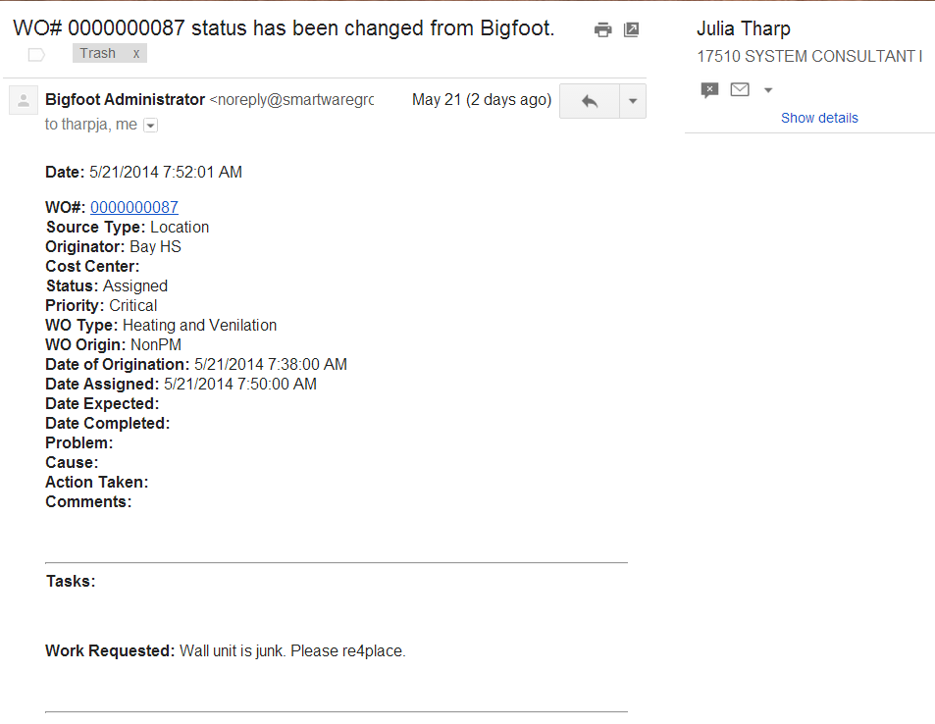
Remember if you have an Emergency:
Enter request into the Bigfoot CMMS system and get a work order number.
Call into Work Control @ 767-1821 and give the work order number

WORK ORDER TITLE:
BLK - Block, Concrete, Stucco, Brick
BLR - Boiler
CRP - Carpentry
DEL - Pick Up & Delivery of Mowers, Pressure Washers, Anything Self Help that needs to be delivered
EAM - Vacuums, Mowers, Small Engines/ Vehicle Maintenance
(Equipment /Auto Mech)(NO GOLF CARTS)
ELE - Electric (used bulbs will be picked up monthly on pm work order)
EQO - Tree trimming, hauling dirt-sand, Mowing, Back Hoe Work,
(Equipment Operator)
FSR - Food Service (Any Equipment in the Kitchen)
(Not Fridge/Freezers)(Not Food Labs)
HVA - Heating, Ventilation, A/C, Refrigerators, Freezers, Ice Machines, Milk Boxes
IRR - Irrigation
LCK - Locks, Doors, Windows
PLM - Plumbing
PNT - Paint, Sheetrock
PST - Pest Control (bugs/pests)
RFC - Roof Contractor
SSR - Self Service
STA - Stadium
WSH - Welding/Sheet metal, gutter

APPENDIX
MAINTENANCE OF FACILITIES 6.508 The Maintenance Department shall be responsible for major repairs and the maintenance of buildings and equipment for the District. The number of Maintenance Department employees required to hold the Commercial Driver License (CDL) will not exceed twenty-five percent (25%) of the total number employed by the Maintenance Department at any given time. As facility manager, the principal is responsible for maintaining his/her assigned facility in an attractive, clean, healthy and safe condition that will enhance the educational program. The principal or administrator shall be responsible for initiating all maintenance requests of the school or facility. Maintenance services must be requested by forwarding a work request form to the Maintenance Department for approval and forwarding of copies to the appropriate persons. In case of an emergency which endangers the lives, health or safety of students or other persons, the principal or other person acting in his/her absence shall report the need for emergency repairs by telephone to the Supervisor of Maintenance. Authority: § 1001.41, Fla. Stat. Law Implemented: 1001.42, Fla. Stat. History: New, June 12, 1989 Revised: November 8, 1989, August 8, 1991 CHAPTER SIX B

BUILDING INSPECTIONS 6.512 Each school building or other facility shall be inspected annually for compliance with the fire safety and sanitation standards of Chapter 2, State Board of Education Rules. Such inspections shall be made by personnel certified by the Department of Education to perform such inspections. The inspecting officer shall use approved inspection forms and provide one copy of the report to the Superintendent, one to the school principal, and one to the Department of Education. Deficiencies reported that are determined to be an immediate danger to life shall be corrected immediately. The School Board shall be advised of such deficiencies and of corrective action. Other hazardous conditions shall be corrected in the following priority: 1. Causative factors of fire, accidents, and contagion. 2. Effective egress of facilities. 3. Early detection of fire. 4. Prevention of the spread of fire and unsanitary conditions. 5. Fire protection equipment, machine guarding, and personnel protection. Authority: § 1001.41, Fla. Stat. Law Implemented: §§ 1013.12, 1001.42, Fla. Stat. History: New, June 12, 1989

LONG-RANGE FACILITY PLANNING 6.515 The Superintendent shall develop and implement procedures for periodically recommending revisions to the Long-Range School Facility Program for approval of the School Board. Such Program shall be based upon the latest School Plant Survey conducted or approved by the Department of Education and shall form the basis for: 1. Acquisition of school sites; 2. Erection of new buildings; 3. Expansion of existing buildings; 4. Modernization and rehabilitation of existing buildings. 5. Re-purposing or closing of schools; 6. Re-zoning of attendance areas. An amended Educational Plant Survey should be performed whenever a school enrollment meets any of the following conditions: 1. Decline of 5% per year for a period of five (5) years; 2. Less than 60% of permanent capacity after being in operation for five (5) years; 3. Exceeds the permanent capacity by more than 25%. Authority: § 1001.41, Florida Statute Law Implemented: §§ 1001.42; 1001.51; 1013.31, Fla. Stat. History: New, June 12, 1989 Revised: May 26, 2004

