Student Retention Plan  TOM P. HANEY TECHNICAL COLLEGE | 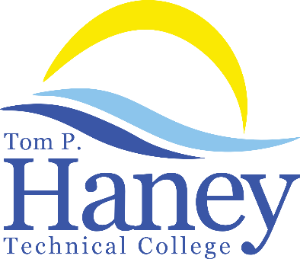

Goals & Objectives
Tom P. Haney Technical College acknowledges the critical importance of student retention in all programs. This allows students to meet educational and employment goals, develops a skilled labor force for the community, and provides financial stability for the institution. The school’s objective is to provide the tools and institutional experiences necessary to maintain consistent student retention rates.

Activities to Achieve Objectives
- Conduct student surveys which give the students an opportunity to voice their opinions on all aspects of the program and college by providing anonymous surveys to protect their identities and allowing them to provide positive or negative feedback without prejudice.
- Conduct a staff survey which provides a platform for the staff to anonymously provide their opinions on the school’s ability to provide a quality learning and working environment.
- Use IPEDS (Integrated Postsecondary Education Data System) to compare the school to others schools for institution-level data on student enrollment, graduation rates, student charges, program completions, faculty, staff, and student finances.
- Analyze the completion data in the COE Annual Report.
- Conduct progress meetings between individual students and Student Services staff after each Occupational Completion Point to chart achievement and employment in field.
- Utilize the data collected to work toward continuously improving the services provided to the student body, and ensuring that the school's faculty and staff have the proper resources to fulfill their job duties.

Input from Faculty, Students, and Stakeholders
Feedback is solicited from staff, students, and stakeholders (industry partners, employers, community members) via annual surveys. These anonymous questionnaires are used to compile information to determine if the school is meeting the personal and educational needs of all staff, students and stakeholders. This gives the school real-time feedback for the following: instructor performance, program organization, clear learning objectives, job readiness, equipment, enrollment process, facility cleanliness, and more. Those surveyed are encouraged to make suggestions for improvement and to point out the programs’ and school’s strengths and weaknesses.

The administrative and instructional staff members complete surveys annually—the Bay District Schools Climate Survey and the Tom P. Haney Technical College COE Staff Survey. Every survey is anonymous. This gives the school the opportunity to receive non-biased opinions regarding the school’s commitment to providing the necessary tools, equipment, technology, staff development opportunities, and support to successfully complete the school’s mission. The school’s administrators utilize this information for continuous improvement planning and long-term strategic planning.

Factors with Positive Impact Upon Student Retention:
- Low cost of tuition, books, and supplies
- Progress meetings between individual students and Student Services staff after each Occupational Completion Point to chart achievement and employment in field
- Wrap-Around Services to decrease student’s barriers to learning or attendance such as Food Bank, Clothing Assistance, Mental Health Counseling Referrals, etc.
- Transportation Referrals such as Trolley Passes or gas cards via Foundation Scholarships
- Employment Assistance via a full-time Career Specialist
- CareerSource Gulf Coast satellite offices on campus with full-time staffing
- Success Academy resources to provide remediation and instruction in computer basics, math, language, and reading basic skills, and the implementation of online training for all career technical students in employability skills and financial literacy. Success Academy Instructors also facilitate testing and if needed, remediation, for students to meet basic skills requirements for program completion purposes.

Personnel Responsible for Overseeing the Plan
The Director or designee is directly responsible for overseeing the completion of the surveys. The administrators analyze the surveys gathered. This information is used for continuous instructional, campus, and program improvement. It also plays a large role in determining the effectiveness of programs regarding student retention

Review/Evaluation/Revision
Annually, the administrative team reviews the survey questionnaires to determine any changes that need to be made. A full year’s worth of data provides an in-depth look at the year in review, and the administrative team studies all data from the surveys. Identifying clear improvement trends and areas of need are the primary focus of the survey process and Student Retention Plan. Overall survey results are shared with the staff and Institutional Advisory Committee/Educational Consortium which includes representatives from industry, administration, instructional staff, support staff, and students. The COE Annual Report is shared annually with staff and faculty during staff meetings and with the Institutional Advisory Committee/Educational Consortium during one of the quarterly meetings. Individual program completion, placement, and licensure rates (if applicable) are shared with the Occupational Advisory Committees on an annual basis. Any individual issues pertaining to a specific instructor or program are discussed in private by administration with the program’s instructor(s). Relevant improvements or changes suggested by any of the above are considered for addition or changes to the Student Retention Plan. The plan is shared annually with all staff via email and is housed on the school’s V Drive which is available to all staff for review and revision as needed. It is also located on the school’s website under the Disclosures link.

