Student Services  Effectiveness Plan | 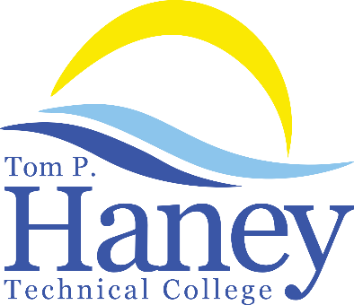

Personnel Responsible for Student Services
The Student & Financial Services Administrator is the direct supervisor for Student Services and Financial Aid.

Goals & Objectives
Tom P. Haney Technical College takes great pride in ensuring that its program offerings consistently deliver the desired education and occupational skills necessary for gainful employment opportunities. This cannot just be measured by the completion and job placement statistics alone. In order to obtain this information the school implements detailed student and staff surveys. Listed below are the goals and objectives of this plan
- Give the students an opportunity to voice their opinions on all aspects of the program by providing anonymous surveys to protect their identities and allow them to provide positive or negative feedback without prejudice.
- Provide a platform for the staff to anonymously provide their opinions on the school’s ability to provide a quality learning and working environment.
- Utilize the data collected to work toward continuously improving the services provided to the student body, and ensuring that the school's faculty and staff have the proper resources to fulfill their job duties.
- Provide for the counseling of students.

Activities to Achieve Objectives
Tom P. Haney Technical College conducts a survey each year and feedback is solicited from staff, students, and stakeholders (industry partners, employers, and community members). These anonymous questionnaires are used to compile information to determine if the college is meeting the personal and educational needs of all staff, students and stakeholders. This gives the school real-time feedback for the following: instructor performance, program organization, clear learning objectives, job readiness, equipment, enrollment process, facility cleanliness, and more. Those surveyed are encouraged to make suggestions for improvement and to point out the program’s and school’s strengths.

The administrative and instructional staff members complete surveys annually—the Bay District Schools Climate Survey and the Tom P. Haney Technical College Staff Survey. Every survey is anonymous. This gives the school the opportunity to receive non-biased opinions regarding the school’s commitment to providing the necessary tools, equipment, technology, staff development opportunities, and support to successfully complete the school’s mission. The school’s administrators utilize this information for continuous improvement planning and long-term strategic planning.

Student Counseling:
The Career Specialist and School Counselor have an open-door policy and are available Monday through Friday. Students who are interested in enrolling are offered a tour of the school and are also provided information about the various programs in order to make the best enrollment match for ability and interest. The Career Specialist provides assistance with job placement and offers Resume Workshops for any current or former students. The School Counselor and Career Specialist are the first point-of-contact for counseling students. If further assistance is needed, administration is consulted for direction/assistance, and Bay District Schools offers resources at the district level to assist with various needs.

Personnel Responsible for Overseeing the Plan
The Director or designee is directly responsible for overseeing the completion of the surveys. The administrators analyze the surveys gathered. This information is used for continuous instructional, campus, and program improvement. It also plays a large role in determining the effectiveness of Student Services and the instructional staff teaching methodology. Overall survey results are shared with the staff and Educational Consortium/Institutional Advisory Committee. Any individual issues pertaining to a specific instructor or program are discussed in private by administration.

Review/Evaluation
Anonymous student and staff surveys are conducted annually which includes questions about Student Services. Administration reviews the survey results to gather input about the effectiveness of Student Services.

Data Sharing/Plan Evaluation and Revisions
Evaluation results of the student and staff surveys are shared with faculty and staff on an annual basis at staff meeting. Administration uses survey results to make continuous improvement at the college. The plan is shared with faculty and staff annually via email with requests for suggestions, and the plan is revised as needed. The plan is also housed on the digital V Drive which is accessible to all staff.

